# Persona:

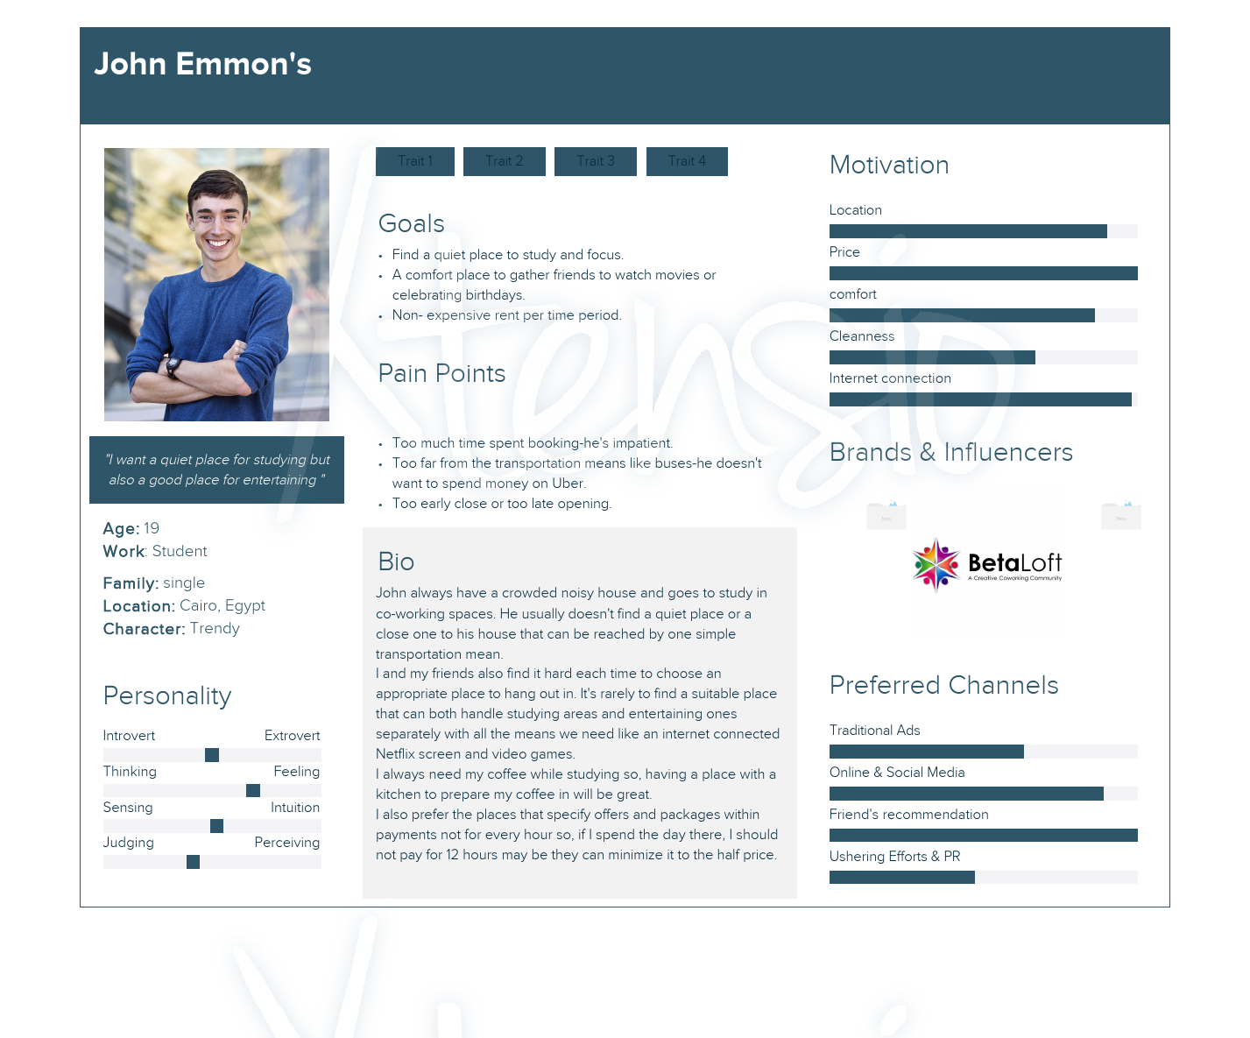

# Usability:

* + 1. Effectiveness:

One of the tasks that the website should support is ‘Booking’, where the user is asked to fill a form. Also, the website can display the rooms available to the user in the ‘Gallery’ page.

* + 1. Efficiency:

The action performed on the website takes almost no time, like changing pages, and booking a room.

* + 1. Safety:

The user data is safely processed without risk of any leaks.

* + 1. Utility:

There is only one function that is implemented in the website which is booking a room and it is simple to use.

* + 1. Learnability:

The user interface is very clear and simple, and the services pages is descriptive of what type of info the user needs to submit.

* + 1. Memorability:

With good learnability the user won’t have any problem remembering the use of the services that the website provides.

1. Affordances:

The affordances are the perceived and actual properties of an object, which help the user determine how to use or interact with it. When they are used, the user knows what to do just by looking at it.

i.e.: the logos of ‘Discord’, ‘Facebook’, And ‘twitter’ in the footer of the website, they launch their respective sites. They are perceptual affordances.

1. Visibility:

When the number of possible actions exceeds the number of controls, some functions become invisible, resulting in complexity. It should be obvious what a control is used for.

i.e.: the buttons, dropdown lists, and checkboxes of the services page. The buttons and links in the header and footer.

1. Metaphor:

In user interface design, an interface metaphoris a set of user interface visuals, actions and procedures that exploit specific knowledge that users already have of other domains.

i.e.: when you hover over an underlined text and it lights up, this indicates that it is a link to another page or to another part of the same page.

Functional requirements:

1- A section to show the place room’s gallery and types of available spaces.

2- A section to show the services the place offers and if someone is interested to reserve.

3- The user can select one of the rooms in the place and reserve it for a particular time

4- The user would be given a unique ID which can be printed and checked-in offline whenever he goes to the place.

5- A section to show the past events held on in the place and client’s reviews.

6- It will be allowed to the client to have a membership with the place for a particular period to have more special offers.

7- There will be an alert message to confirm the payment and the whole membership with an ID.

Non-functional requirements:

1- The user cannot reserve a previously reserved room.

2- The payment methods should not appear to the client until he completes his data and agrees to the place rules.

3- The website should be responsive.

4- The alert message should appear quickly after the client submit the membership payment.

5-The data of the client should be saved when he makes a reservation or for the membership.